What is AI Technique?
In the real world, the knowledge has some unwelcomed properties −
- Its volume is huge, next to unimaginable.
- It is not well-organized or well-formatted.
- It keeps changing constantly.
AI Technique is a manner to organize and use the knowledge efficiently in such a way that −
- It should be perceivable by the people who provide it.
- It should be easily modifiable to correct errors.
- It should be useful in many situations though it is incomplete or inaccurate.
AI techniques elevate the speed of execution of the complex program it is equipped with.

Top 4 Techniques of Artificial Intelligence
Artificial Intelligence can be divided into different categories based on the machine’s capacity to use past experiences to predict future decisions, memory, and self-awareness. IBM came up with Deep Blue, a chess program that can identify the pieces in the chessboard. But it does not have the memory to predict future actions. This system though useful but it cannot be adapted to another situation. Another type of AI system which uses past experiences and it has the bonus of a limited memory to predict the decisions. An example of this kind of AI system can be found in the functions of decision making in case of the self-driving cars. Here the observations help in the actions to be taken shortly which does not get stored permanently as the observations change frequently. At the same time with the advancement in technology, it might be possible to have machines with a sense or consciousness where the machines understand the current state of things, which can be used to infer what is to be done. But such systems do not exist.
Below are the various categories of Artificial Intelligence:
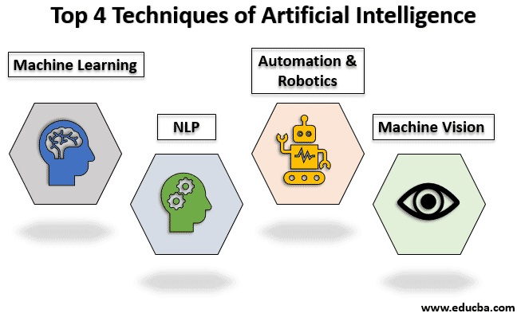

1. Machine Learning
It is one of the applications of AI where machines are not explicitly programmed to perform certain tasks rather they learn and improve from experience automatically. Deep Learning is a subset of machine learning based on artificial neural networks for predictive analysis. There are various machine learning algorithms such as Unsupervised Learning, Supervised Learning, and Reinforcement Learning. In Unsupervised Learning, the algorithm does not use classified information to act on it without any guidance. In Supervised Learning, it deduces a function from the training data which consists of a set of an input object and the desired output. Reinforcement learning is used by machines to take suitable actions to increase the reward to find the best possibility which should be taken in to account.

2. NLP (Natural Language Processing)
It is the interactions between computers and human language where the computers are programmed to process natural languages. Machine Learning is a reliable technology for Natural Language Processing to obtain meaning from human languages. In NLP, the audio of a human talk is captured by the machine. Then the audio to text conversation occurs and then the text is processed where the data is converted into audio. Then the machine uses the audio to respond to humans. Applications of Natural Language Processing can be found in IVR (Interactive Voice Response) applications used in call centers, language translation applications like Google Translate and word processors such as Microsoft Word to check the accuracy of grammar in text. However, the nature of human languages makes the Natural Language Processing difficult because of the rules which are involved in the passing of information using natural language and they are not easy for the computers to understand. So NLP uses algorithms to recognize and abstract the rules of the natural languages where the unstructured data from the human languages can be converted to a format that is understood by the computer.

3. Automation and Robotics
The purpose of Automation is to get the monotonous and repetitive tasks done by machines which also improve productivity and in receiving cost-effective and more efficient results. Many organizations use machine learning, neural networks, and graphs in automation. Such automation can prevent fraud issues while financial transactions online by using CAPTCHA technology. Robotic process automation is programmed to perform high volume repetitive tasks which can adapt to the change in different circumstances.

4. Machine Vision
Machines can capture visual information and then analyze it. Here cameras are used to capture the visual information, the analog to digital conversion is used to convert the image to digital data and digital signal processing is employed to process the data. Then the resulting data is fed to a computer. In machine vision, two vital aspects are sensitivity, which is the ability of the machine to perceive impulses that are weak and resolution, the range to which the machine can distinguish the objects. The usage of machine vision can be found in signature identification, pattern recognition, and medical image analysis, etc.

Applications of Artificial Intelligence
Below are the various applications of artificial intelligence.
- AI is used in the finance industry where personal data is collected which can be later used to provide financial advice.
- AI is used in the field of education, where the grading system can be automated and the performance of the students can be assessed based on which the learning process can be improved.
- In the field of Healthcare, AI is used to perform a better diagnosis where the technologies used to understand the natural language and respond to the questions asked. Also, computer programs like chatbots are used to assist customers in scheduling appointments and ease of billing process, etc.
- AI is used in Business to automate the repetitive tasks performed by humans with the help of Robotic Process Automation. To increase customer satisfaction, machine learning algorithms are integrated with analytics to gather information which helps in understanding customer needs.
- AI is used in Smart Home devices, security and surveillance, navigation and travel, music and media streaming and video games, etc.

Applications of AI
AI has been dominant in various fields such as −
- Gaming − AI plays crucial role in strategic games such as chess, poker, tic-tac-toe, etc., where machine can think of large number of possible positions based on heuristic knowledge.
- Natural Language Processing − It is possible to interact with the computer that understands natural language spoken by humans.
- Expert Systems − There are some applications which integrate machine, software, and special information to impart reasoning and advising. They provide explanation and advice to the users.
- Vision Systems − These systems understand, interpret, and comprehend visual input on the computer. For example,
  - A spying aeroplane takes photographs, which are used to figure out spatial information or map of the areas.
  - Doctors use clinical expert system to diagnose the patient.
  - Police use computer software that can recognize the face of criminal with the stored portrait made by forensic artist.
- Speech Recognition − Some intelligent systems are capable of hearing and comprehending the language in terms of sentences and their meanings while a human talks to it. It can handle different accents, slang words, noise in the background, change in human’s noise due to cold, etc.
- Handwriting Recognition − The handwriting recognition software reads the text written on paper by a pen or on screen by a stylus. It can recognize the shapes of the letters and convert it into editable text.
- Intelligent Robots − Robots are able to perform the tasks given by a human. They have sensors to detect physical data from the real world such as light, heat, temperature, movement, sound, bump, and pressure. They have efficient processors, multiple sensors and huge memory, to exhibit intelligence. In addition, they are capable of learning from their mistakes and they can adapt to the new environment.

History of AI
Here is the history of AI during 20th century −
Year | Milestone / Innovation
1923 | Karel Čapek play named “Rossum's Universal Robots” (RUR) opens in London, first use of the word "robot" in English.
1943 | Foundations for neural networks laid.
1945 | Isaac Asimov, a Columbia University alumni, coined the term Robotics.
1950 | Alan Turing introduced Turing Test for evaluation of intelligence and published Computing Machinery and Intelligence. Claude Shannon published Detailed Analysis of Chess Playing as a search.
1956 | John McCarthy coined the term Artificial Intelligence. Demonstration of the first running AI program at Carnegie Mellon University.
1958 | John McCarthy invents LISP programming language for AI.
1964 | Danny Bobrow's dissertation at MIT showed that computers can understand natural language well enough to solve algebra word problems correctly.
1965 | Joseph Weizenbaum at MIT built ELIZA, an interactive problem that carries on a dialogue in English.
1969 | Scientists at Stanford Research Institute Developed Shakey, a robot, equipped with locomotion, perception, and problem solving.
1973 | The Assembly Robotics group at Edinburgh University built Freddy, the Famous Scottish Robot, capable of using vision to locate and assemble models.
1979 | The first computer-controlled autonomous vehicle, Stanford Cart, was built.
1985 | Harold Cohen created and demonstrated the drawing program, Aaron.
1990 | Major advances in all areas of AI −  - Significant demonstrations in machine learning  - Case-based reasoning  - Multi-agent planning  - Scheduling  - Data mining, Web Crawler  - natural language understanding and translation  - Vision, Virtual Reality  - Games
1997 | The Deep Blue Chess Program beats the then world chess champion, Garry Kasparov.
2000 | Interactive robot pets become commercially available. MIT displays Kismet, a robot with a face that expresses emotions. The robot Nomad explores remote regions of Antarctica and locates meteorites.

